

2023

**(1)**

**Handout Pemrograman Terstruktur**

Nama : Nim : Kelas :

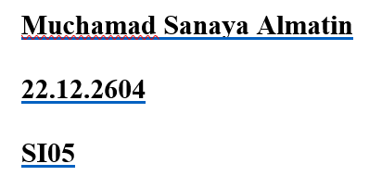***Program Studi S1***

*Disclaimer*

Hanya dipergunakan di Lingkungan Internal Universitas AMIKOM Yogyakarta

Program Studi S1-Sistem Informasi, Fakultas Ilmu Komputer, Universitas Amikom Yogyakarta

***AMIKOM***

**TASK:**

1. An organization is hiring new employees. There were ten candidates. Criteria for passing applicants:

For Women : Minimum height is 160 cm and maximum weight is 65 kg

For Men : Minimum height is 165 cm and maximum weight is 80 kg

Create an algorithm to count how many applicants passed.

1. Create an algorithm to determine the buyer's total cost, the amount paid, and the change.

The seller enters the product's name, the quantity of units purchased, and the product's

unit price.

1. Create an algorithm to print this pattern:

Height: 5

*

**

***

****

*****

**ANSWER:**

1. Algorithm to count how many applicants passed.

**Code:**

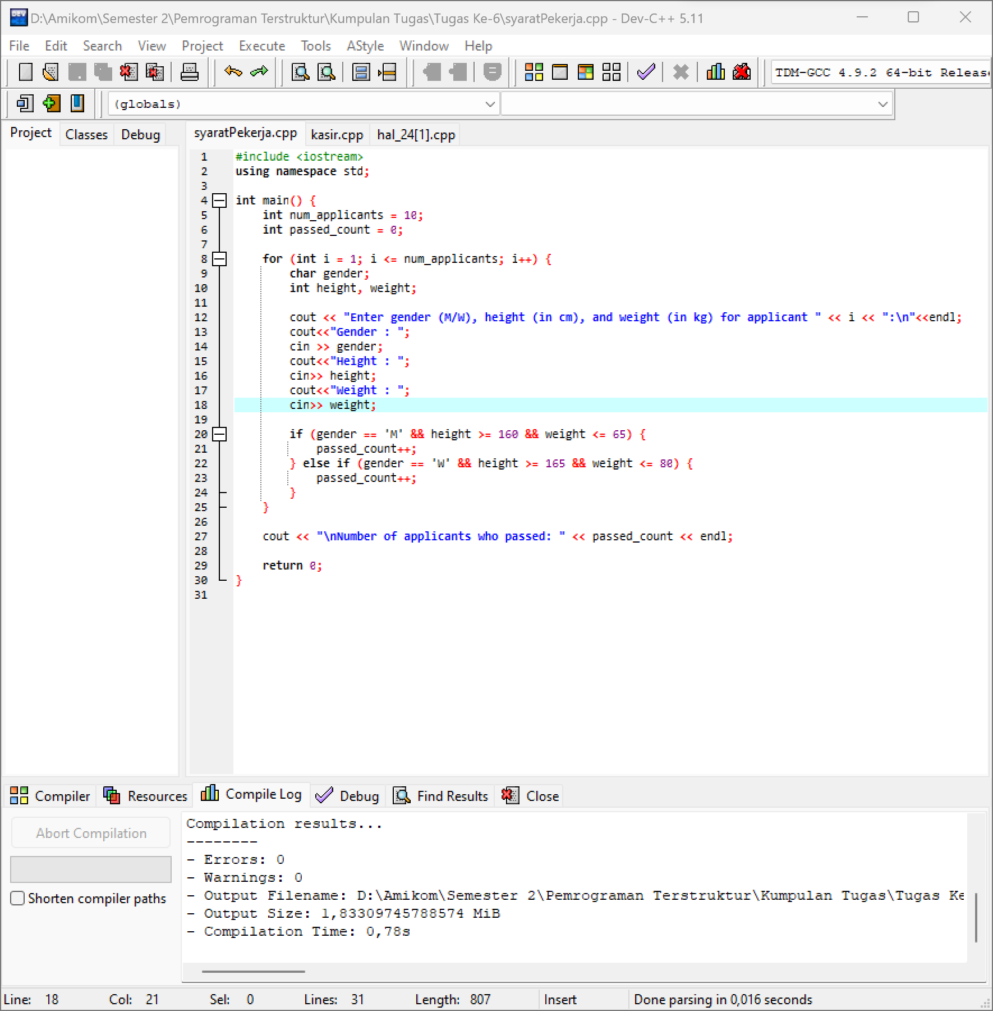

**Result:**

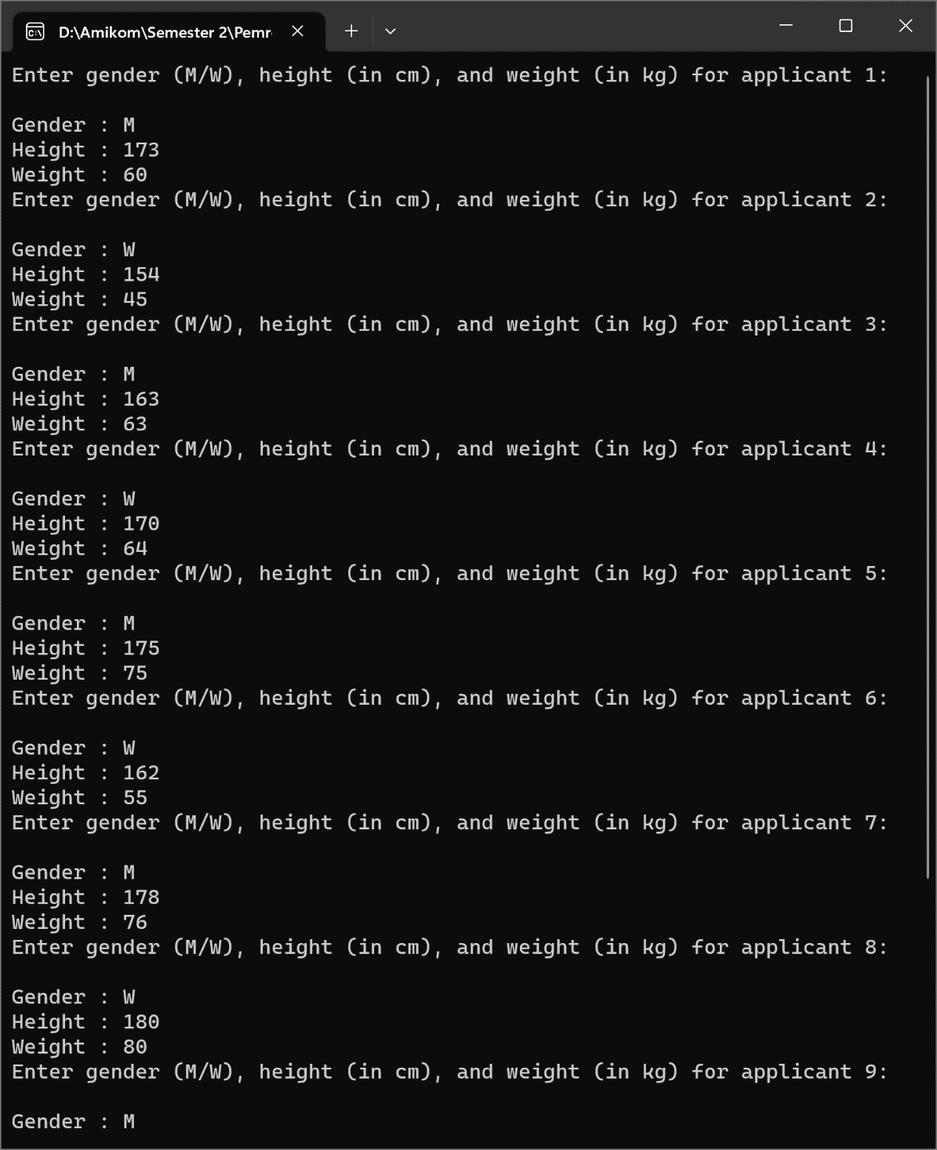

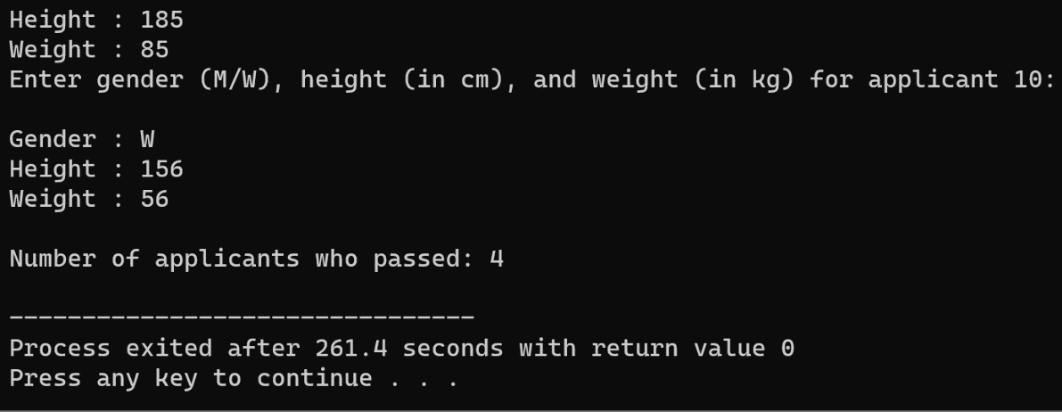

1. Algorithn to determine buyer’s total cost, the amount paid, and the change.

**Code:**

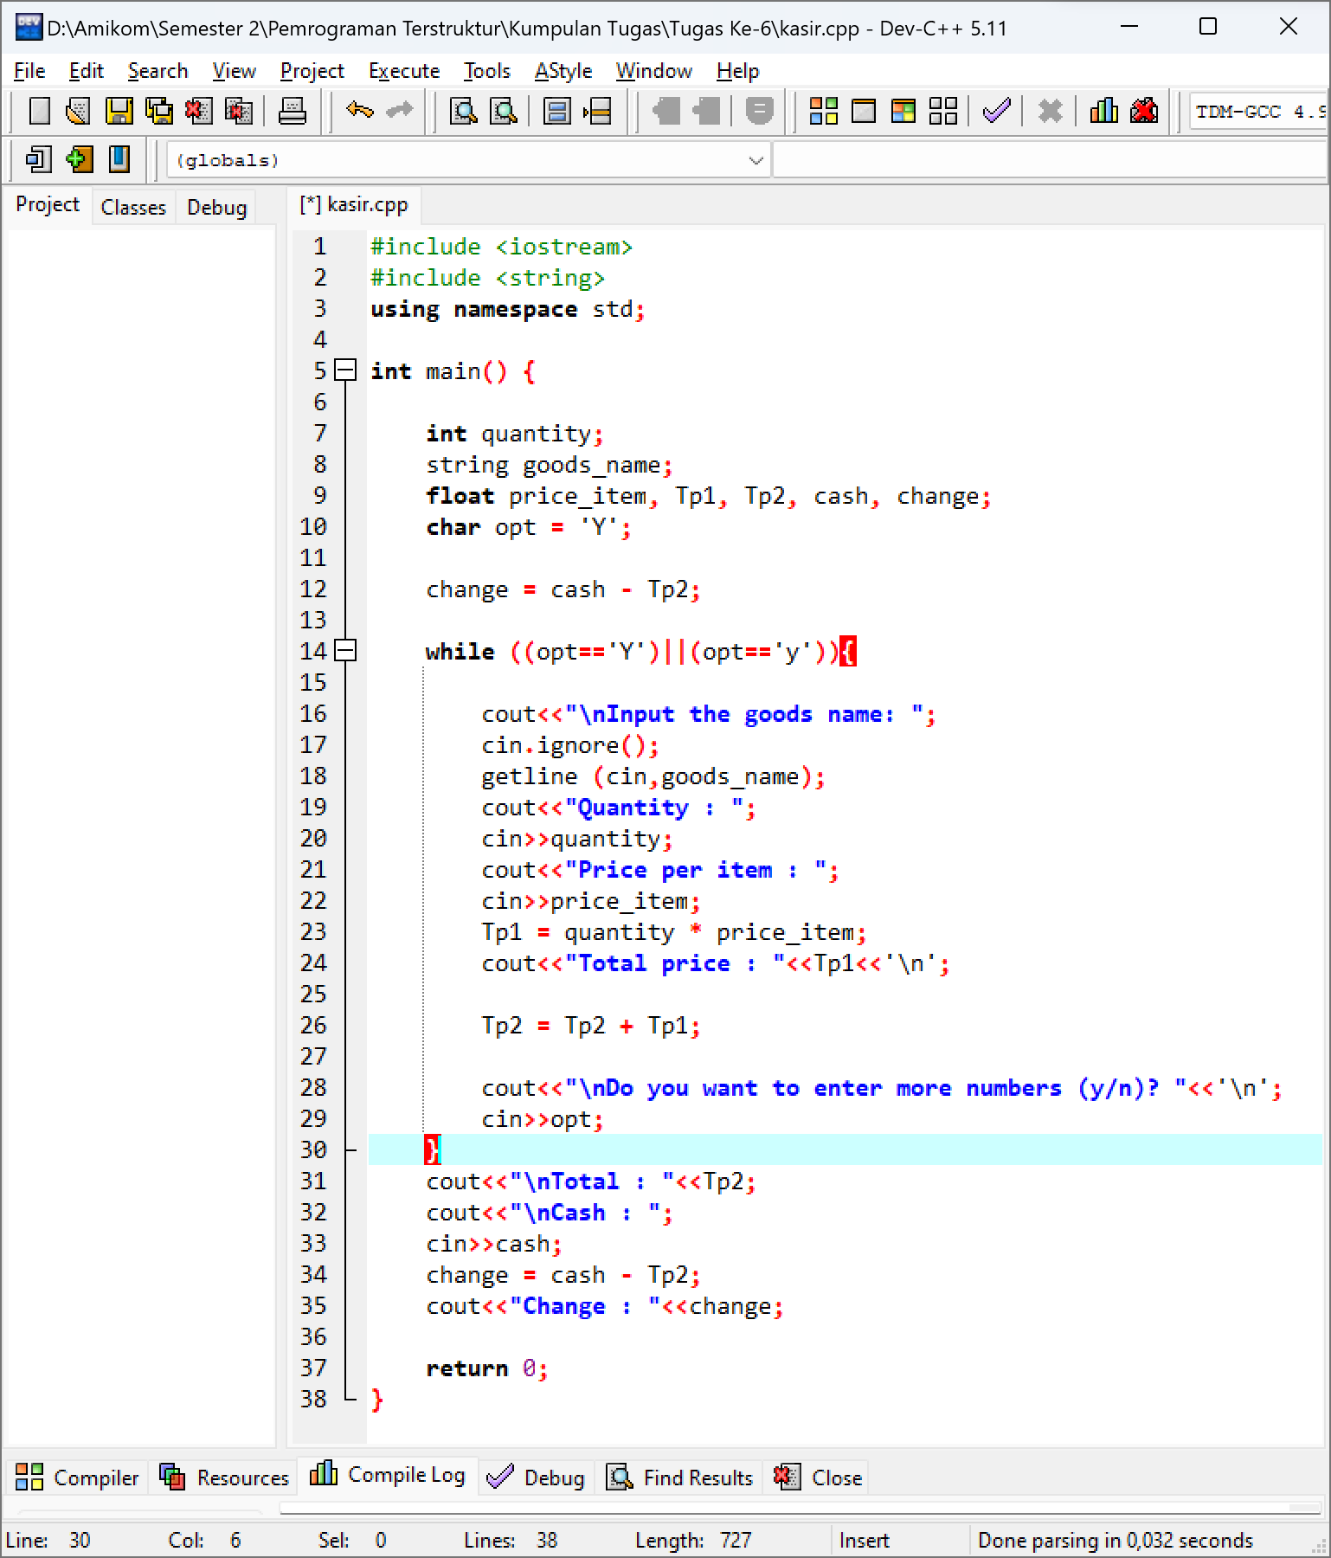

**Result:**

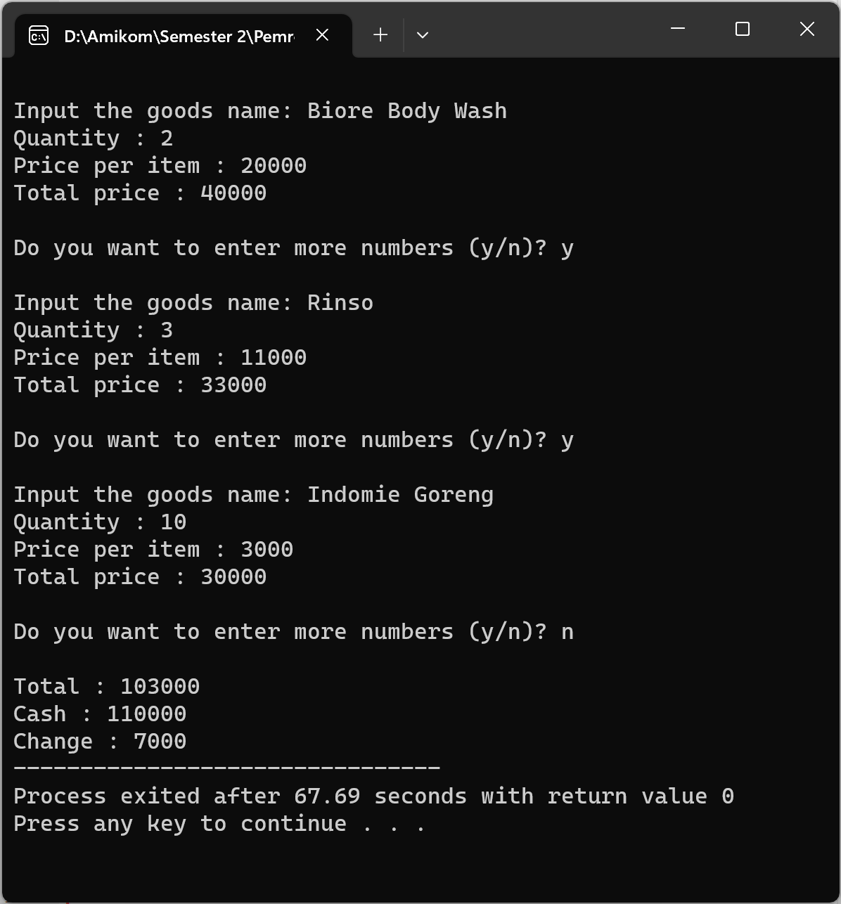

1. Algorithm to print pattern

**Code:**

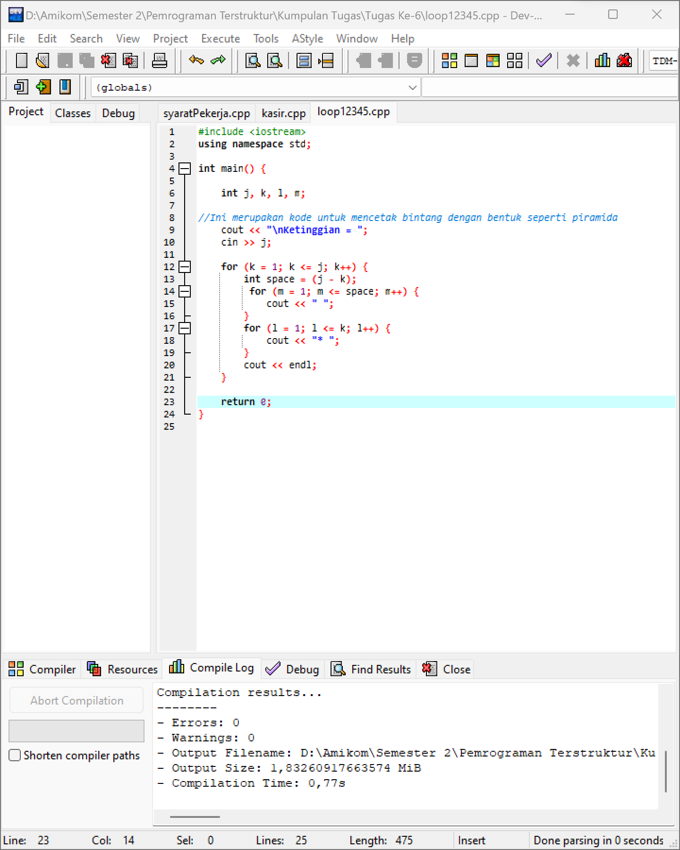

**Result:**

